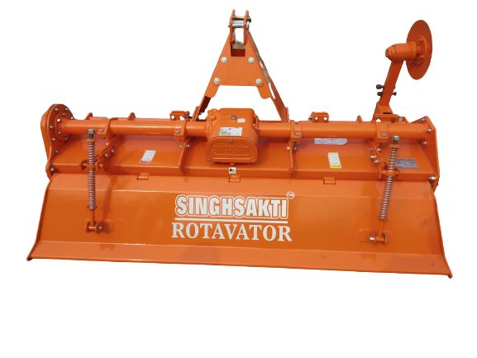 Rotavator plus

Description:-

The Regular Plus is a medium and hard soil rotary tiller with combined features of its predecessors Light and Smart. Available in multiple drives, speeds and blades options; it can produce superior seedbeds for both dry and wet cultivation.

Features:-

Multi Speed Gear Box  
Adjustable lower hitch brackets  
L type Blades  
Chain/Gear Driven Side Transmission in oil bath  
CE Guards for European Markets  
Adjustable skids  
Rear Board Springs